GLY 4310C

LAB 8 INTRUSIVE IGNEOUS ROCKS, PART 3 (and friends)

Prepared by Jyothirmayi Palaparthi

Sample 13. Hornblende Syenite

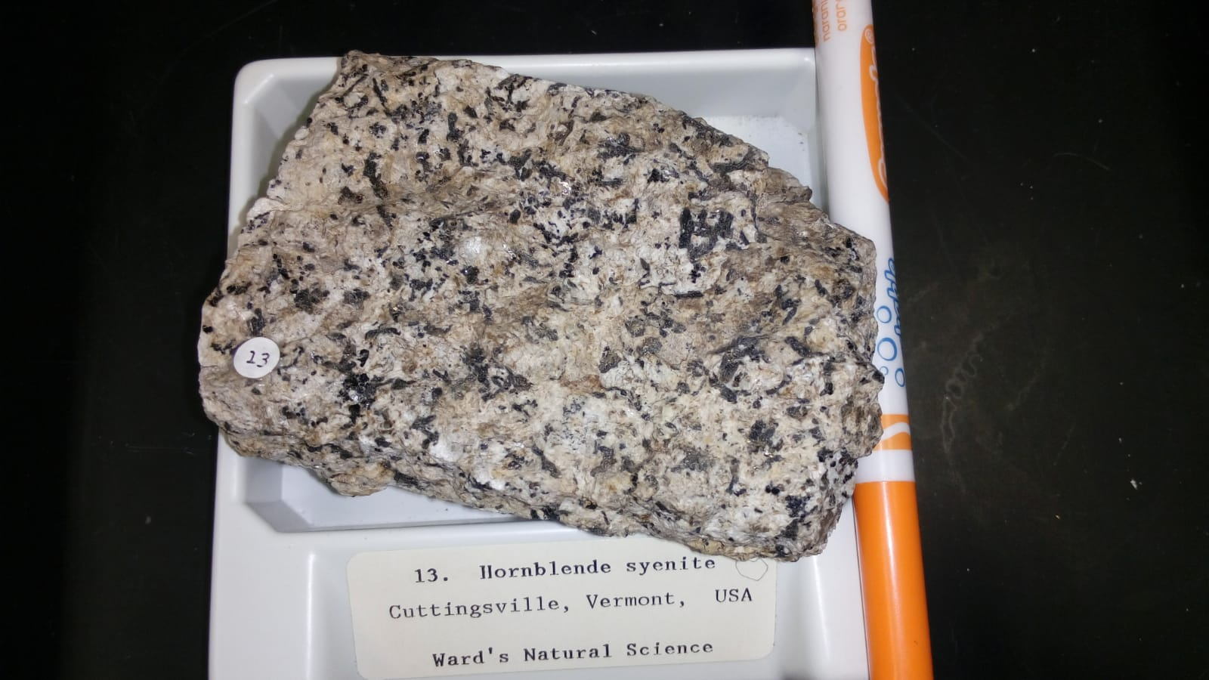

Syenites are coarse-grained intrusive rocks that are relatively rare on Earth. The major mineral is feldspar, with greater than 65% alkali feldspar (K-spar or albite). The ferromagnesian minerals are usually 20%. The K-spar is typically orthoclase, microcline or perthite.

Plagioclase: 20-25%

Quartz: 3%

K-spar: 53-58%

Biotite: 5%

Hornblende: 14%

Hornblende and biotite in igneous rocks: <https://www.youtube.com/watch?v=F9MZKRlyDJM>

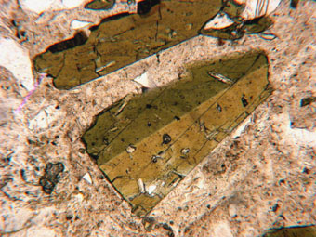

simple twinned crystal of hornblende PPL 50x.

14. Alkali Syenite

Intrusive igneous, plutonic. A syenite rich in sodium, this rock has strongly perthitic K-spars or anorthoclase, and plagioclase is albite to sodic oligoclase. The Mafic minerals include iron-rich biotite, iron or sodic amphiboles including hastingsite, arfvedsonite, or riebeckite, and pyroxene is either aegirine-augite or aegirine. There may be accessory feldspathoids.

Plagioclase: 10%

Felsic: 5%

K-spar: 80%

Hornblende: 0-4%

Clinopyroxene: 0-4%

For more info: <http://www.alexstrekeisen.it/english/pluto/alkalifeldsparsyenite.php>

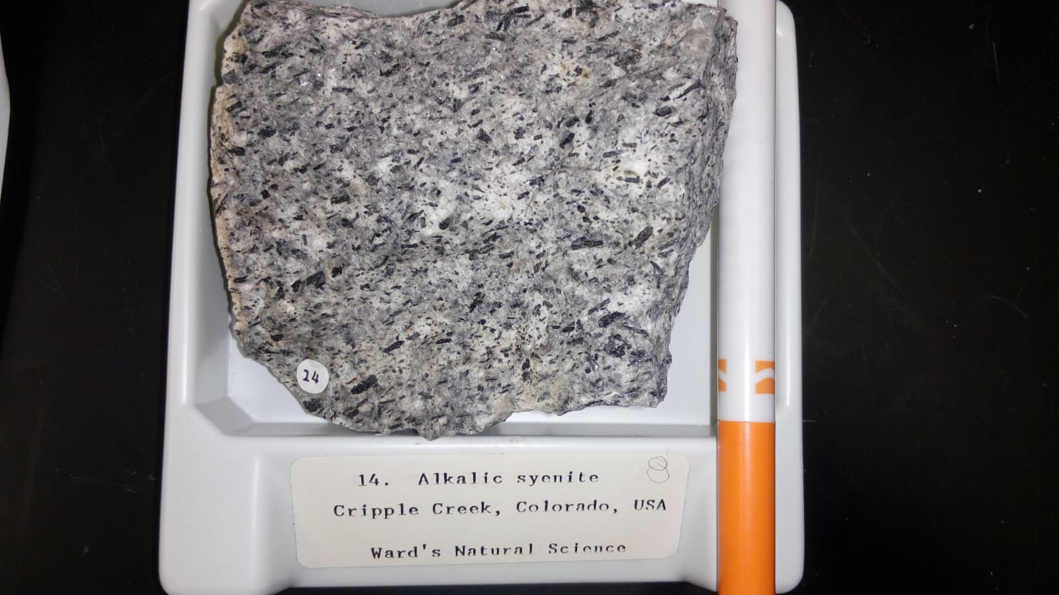

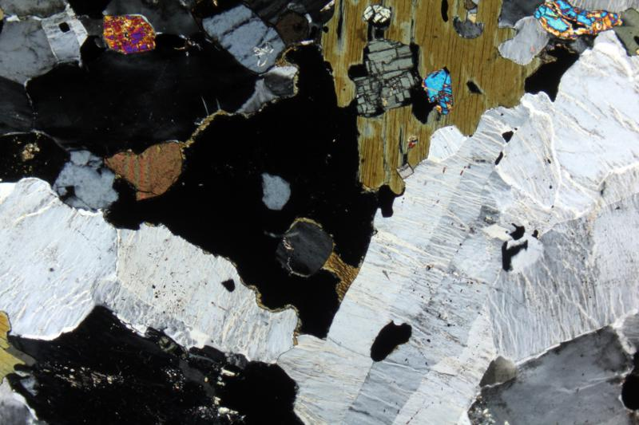

Hornblende and Orthoclase (<https://www.youtube.com/watch?v=FLII1L68gWI>)in a Alkali Fedspar Syenite. XPL image. 2x (Field of view = 7mm)

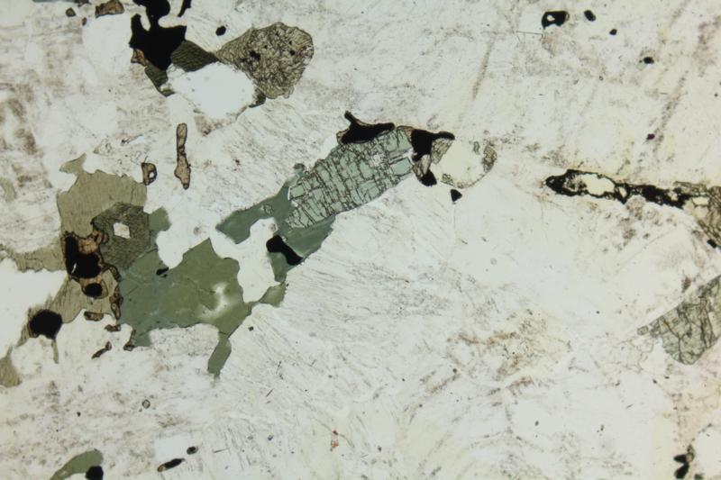

Hornblende (<https://www.youtube.com/watch?v=JmqdWKHOaoU>) in Alkali Fedspar Syenite. PPL image. 2x (Field of view = 7mm)

17. Nepheline Syenite

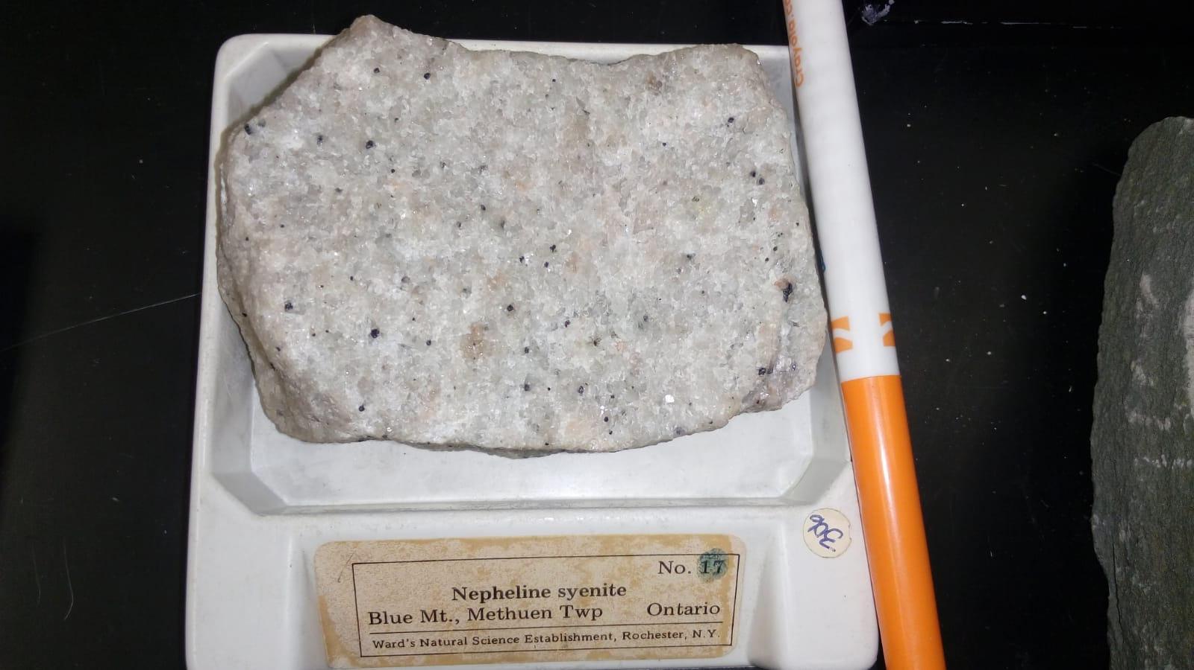

Nepheline has very low relief and is colourless in PPL. Under XPL, it shows 1st order greys, is untwinned and has very little to distinguish it from untwinned K-feldspar.

This sample shows a nepheline syenite in PPL 50x. The bladed, Carlsbad-twinned crystals are K-feldspar. The other minerals are nepheline. (<https://www.youtube.com/watch?v=m_IioirMCbo>)

For more information: <https://digitalfire.com/4sight/material/nepheline_syenite_1069.html>

Intrusive igneous, plutonic. Foid syenite composed of granular aggregates, typically orthoclase, microcline, microperthite, cryptoperthite, or albite. Other felsics include nepheline and possible accessory feldspathoids such as cancrinite, sodalite, hauyne, or nosean. Mafics are soda-rich such as arfvedsonite, hastingsite, aegirine-augite, aegirine, or titanaugite.

Plagioclase: 2%

K-spar: 63-83%

Hornblende: 5-20%

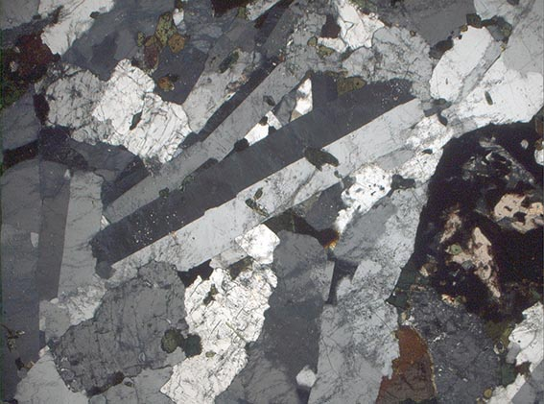

19. Ijolite

Intrusive igneous, plutonic. A feldspathoid-rich rock, containing essential nepheline (50-70%) and pyroxene, generally aegirine. The IUGS classification is F 60-100, M 30-70, and sodium > potassium. Ijolites, carbonatites, and syenites are often associated, and are often rich in alkali elements. The silicate and carbonatite minerals have similar trace and minor element chemistries.

Quartz: 40%

Biotite: 15-20%

Pyroxene: 40-45%

For more information: <http://www.alexstrekeisen.it/english/pluto/ijolite.php>

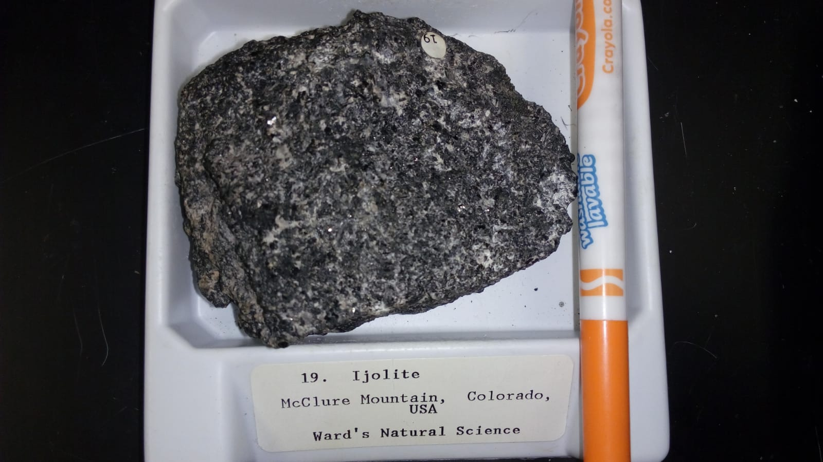

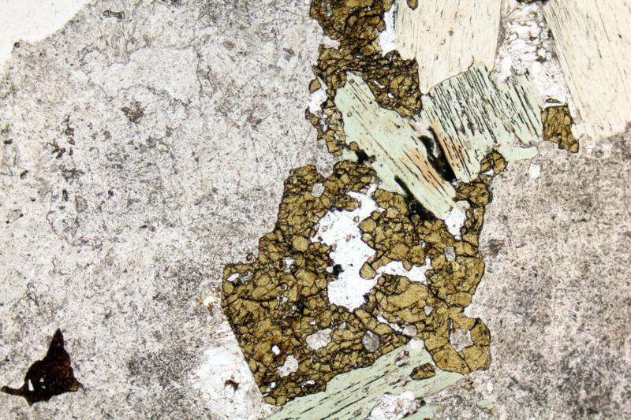

Phlogopite, Andradite (brown) and altered Nepheline (dusty). PPL image, 2x (Field of view = 7mm)

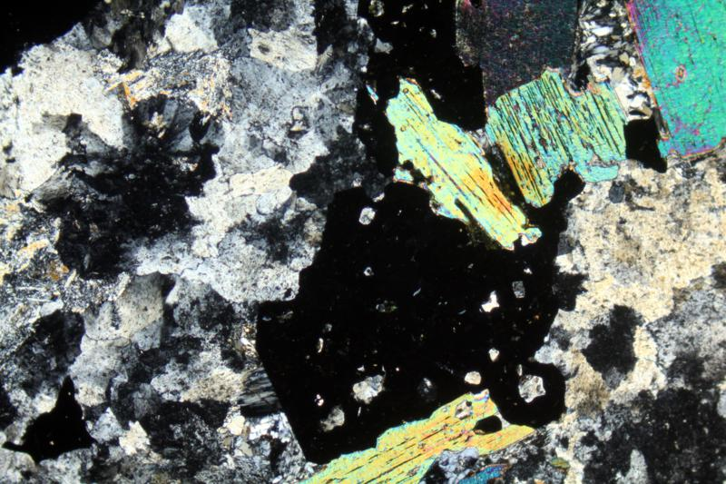

Phlogopite, Andradite and altered Nepheline. XPL image, 2x (Field of view = 7mm)

20. Siderite Carbonate

Intrusive igneous, hypabyssal. This is an igneous rock in which the carbonate minerals are primary. The similarity between silicate and carbonate phase trace and minor elements has convinced most petrologists that the carbonatites must originate together with the silicates, possibly from the same source, and not from limestones, as early workers had suggested. Siderite, calcite, dolomite, or ankerite are usually associated with these rocks.

Quartz: 10%

Medium grained. Layered. CARBONATE - 60%, anh, white to weathered brown, 2 mm, thin bands. SIDERITE - 20%, anh, brown to reddish, < 0.5 mm. PYRITE - Cubic, 2%, 1 mm. LIMONITE - 5% surface coating, yellow, powdery. RARE EARTH CARBONATE or CHLORITE - 3% surface coating, lumpy, blue-green, scattered blotches.

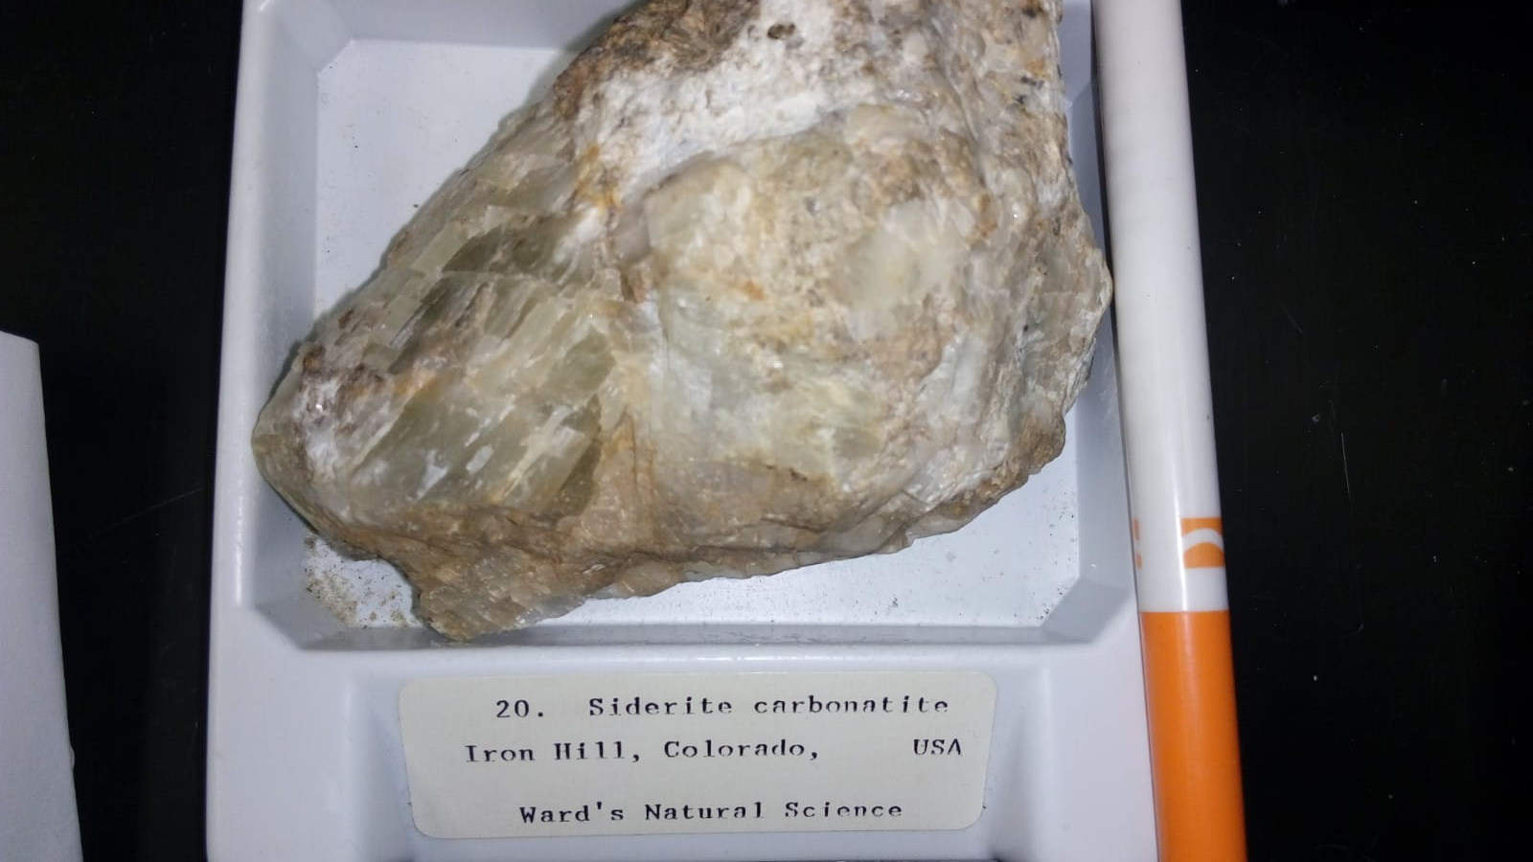

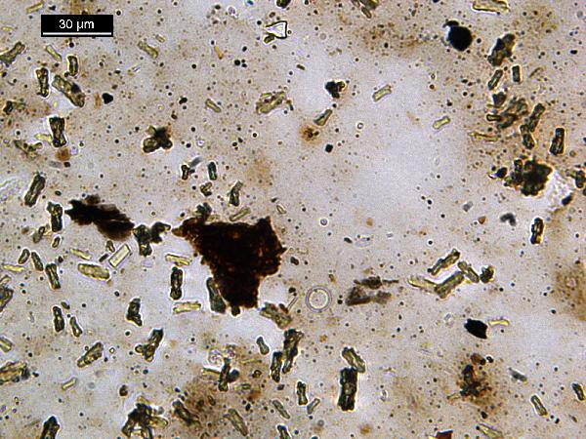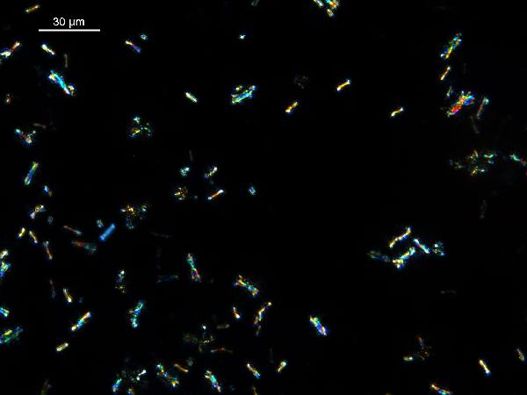

Siderite under PPL 400 x. Twinned flared and elongated minerals.

Siderite under CPL 400 x. Twinned flared and elongated minerals.

21. Phonolite

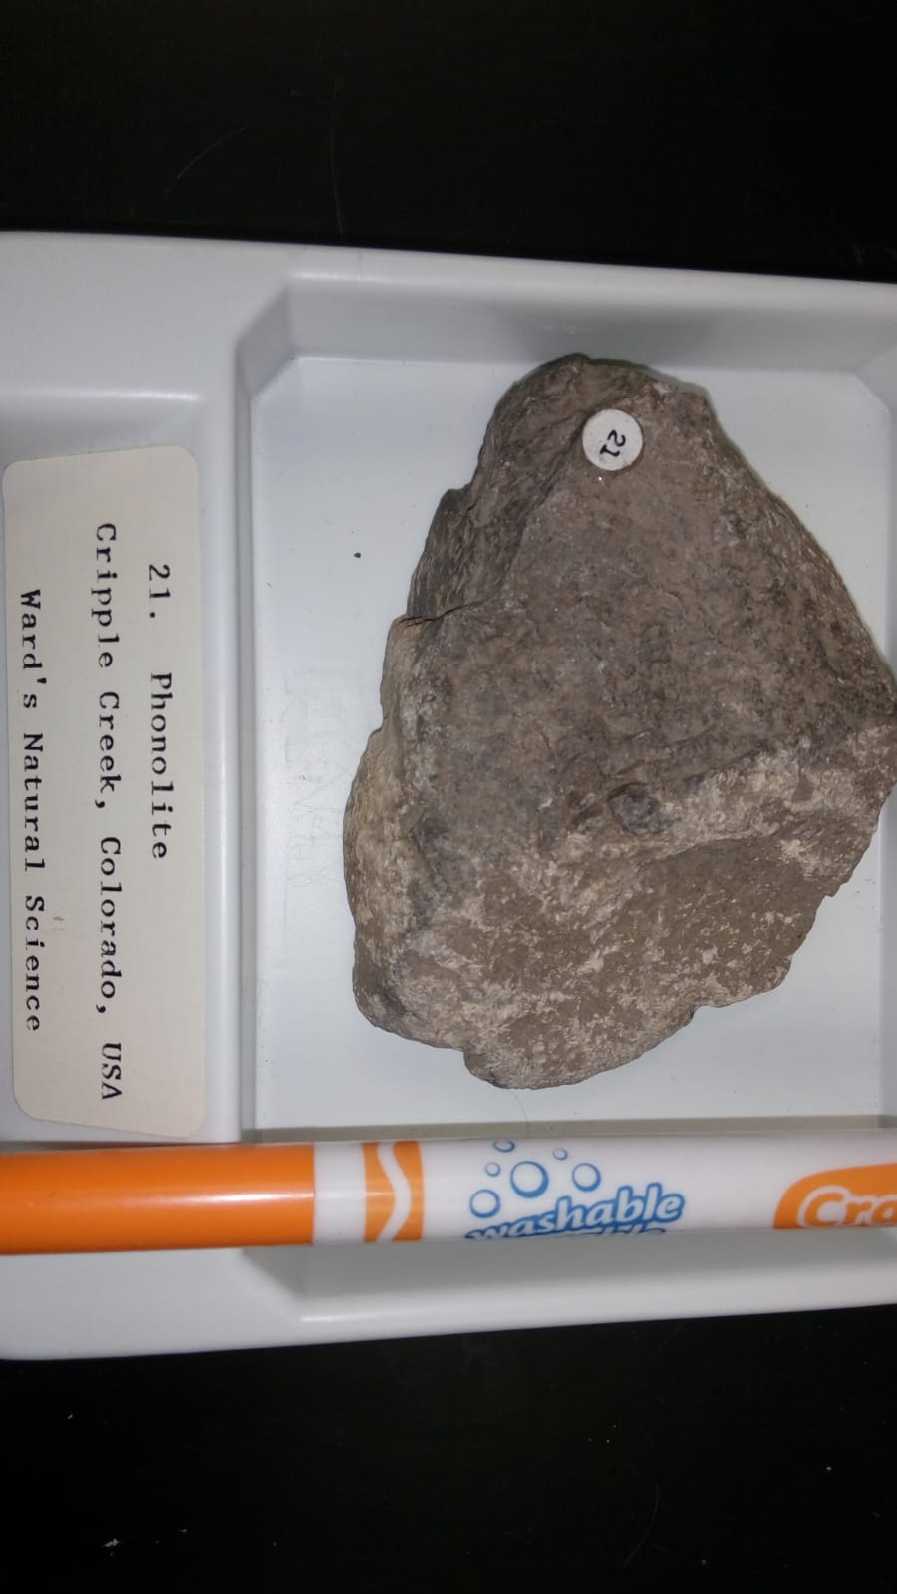

Igneous extrusive, hypabyssal? An aphanitic rock composed of alkali feldspar, often anorthoclase or sanidine, nepheline, and mafics. Other feldspathoids may replace nepheline. The rock is usually a lava, but may occur in shallow dikes.

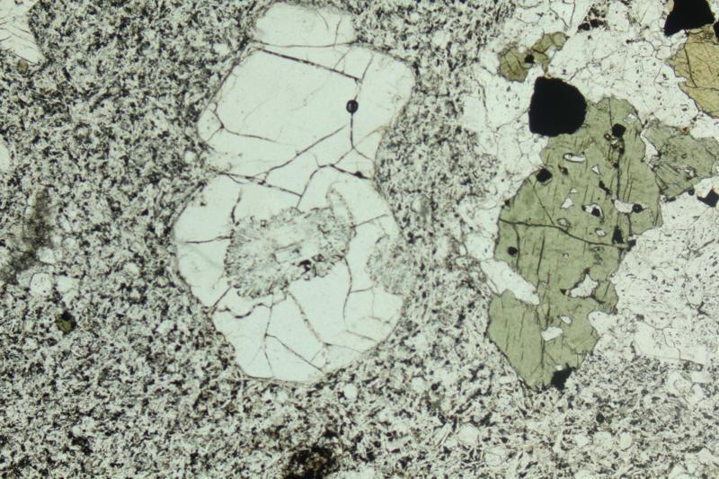

Leucite and clinopyroxene in a Tephritic Phonolite From Acquapendente. PPL image, 2x (Field of view = 7mm)

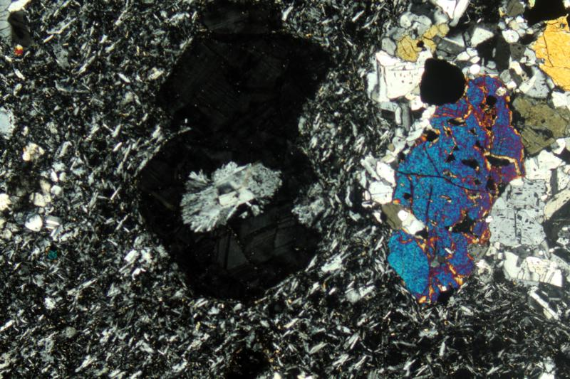

Leucite and clinopyroxene in a Tephritic Phonolite from Acquapendente. XPL image, 2x (Field of view = 7mm)

For more information: <http://www.alexstrekeisen.it/english/vulc/tephriticphonolite.php>

39. Lamprophyre

Intrusive igneous, diaschist. Lamprophyre rocks are melanocratic or mesotype rocks hypabyssal rocks. They contain mafic phenocrysts in a fine-grained groundmass. There are many different rocks grouped under the heading lamprophyre. The usual mafic minerals are olivine (or serpentine), biotite, hornblende (usually green), and pyroxene (green diopside or Fe-Ti augite, which is purplish). The lighter-colored minerals are often alkaline, such as alkali feldspar (K-spar or albite) and Na-rich nepheline. Plagioclase is common, while quartz may be present.

Plagioclase: 5-7%

Olivine: 85-90%

Hornblende: 5-8%

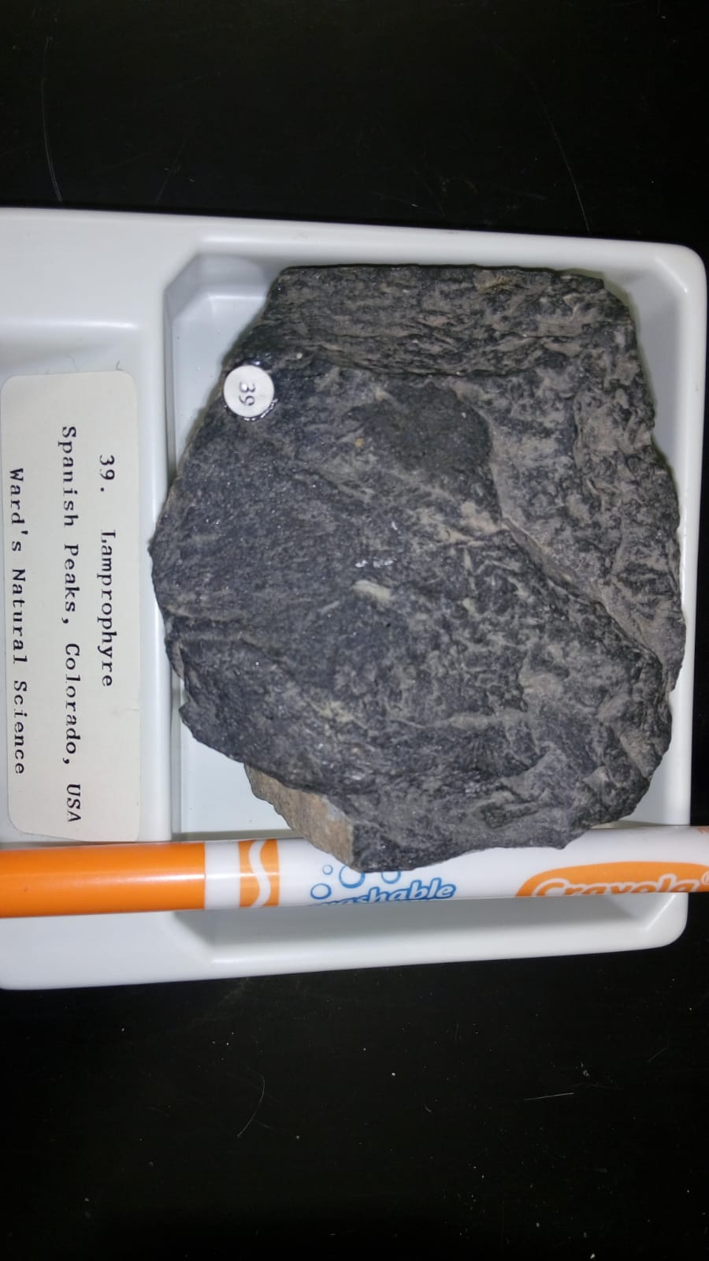

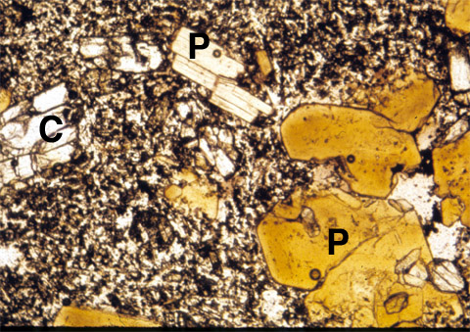

Microscope view (long dimension 2 mm) of a thin section of minette from the Colorado Plateau. Magnesium-rich biotite (P, phlogopite) and clinopyroxene (C) phenocrysts in a groundmass of alkali feldspar, pyroxene, and iron-titanium oxides.

41. Dunite

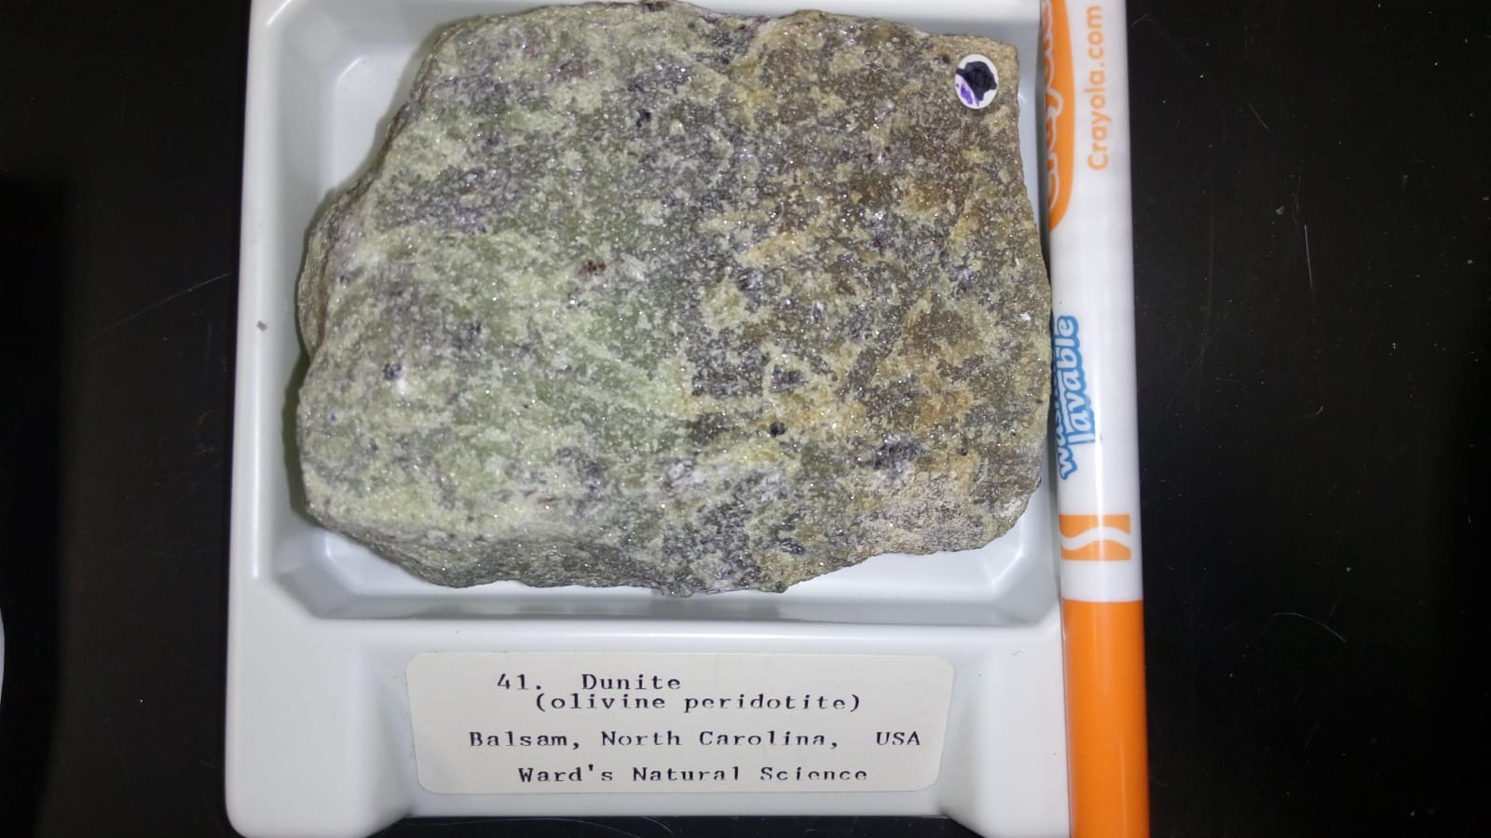

Dunite is olivine peridotite, with > 90% olivine. The mineralogy is similar to the pyroxenites, except that a mica, phlogopite, is often present. The rock is feldspar free.

Olivine: 95-97%

For more information: <http://www.alexstrekeisen.it/english/pluto/dunite.php>

Dunite in CPL: <https://www.youtube.com/watch?v=z7Vn2B524uA>

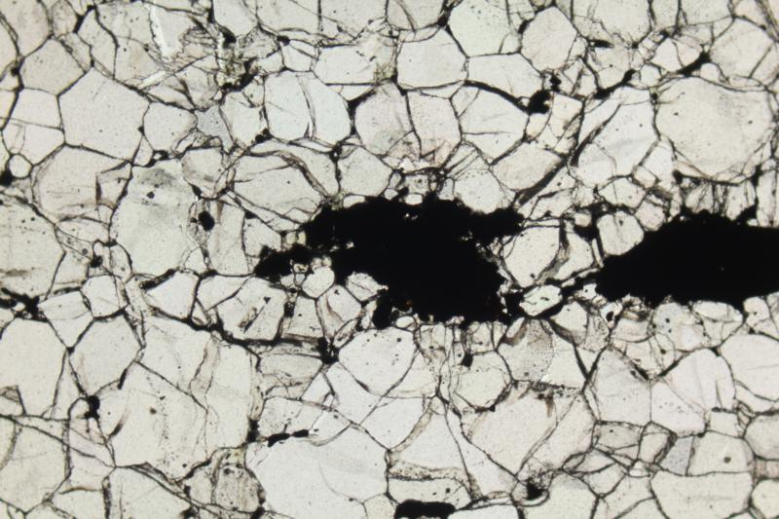

Olivine crystals in a dunite. PPL image, 2x (Field of view = 7mm)

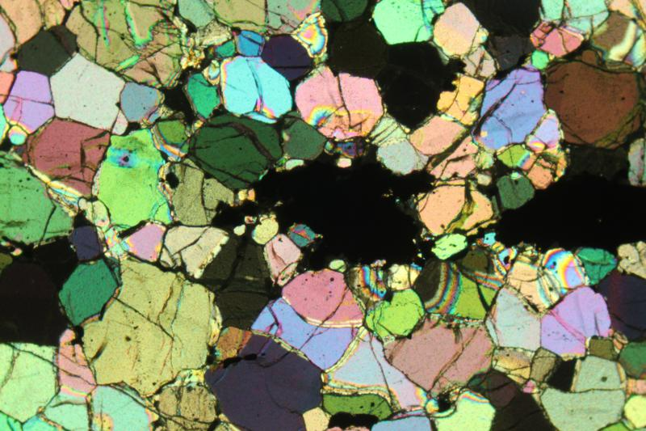

Olivine crystals in a dunite. XPL image, 2x (Field of view = 7mm)

42. Kimberlite

Intrusive igneous, dike or pipe. Kimberlite is a porphyritic peridotite or peridotite breccia that occurs as dikes or in pipes. It contains olivine, usually altered to serpentine, phlogopite (commonly chloritized), and sometimes carbonates. The groundmass is usually calcite, serpentine, chlorite, phlogopite and accessory minerals such as chromian pyrope, ilmenite, magnetite, and perovskite. Some kimberlites are diamond-bearing.

Plagioclase: 3%

Olivine: 40%

Phlogopite: 2%

For more information: <http://cosweb1.fau.edu/~warburton/Spring2020/GLY4310_S20/4310LB8_S20.pdf>

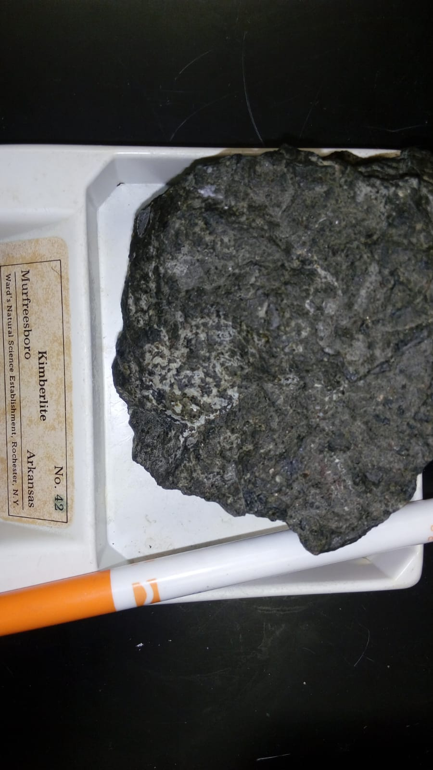

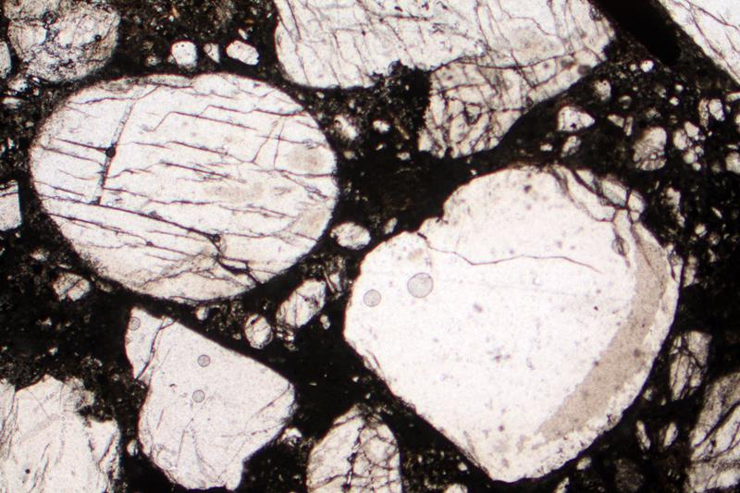

Olivine crystals (rounded and fragmented) set in a dark groundmass composed by carbonates. Hypabyssal kimberlite. Udachnaya-East, Sakha-Yakutia (Russia). PPL image, 2x (Field of view = 7mm)

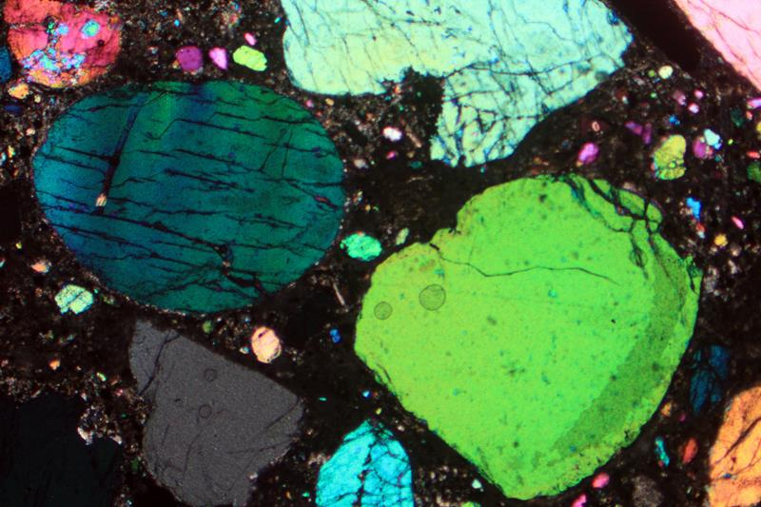

Olivine crystals (rounded and fragmented) set in a dark groundmass composed by carbonates. Hypabyssal kimberlite. Udachnaya-East, Sakha-Yakutia (Russia). XPL image, 2x (Field of view = 7mm)